Noodle Tools to Create a Works Cited
Directions
1. To access Noodle Tools, go to BMCHSD home page and go to Library – Wellington C. Mepham High School
2. Go to Databases – click on ALL
3. Click on Noodle Tools
4. Click on Create Personal ID

5. Register
Make sure First box is checked

6. New User Registration
username: Mepham
password: Mepham

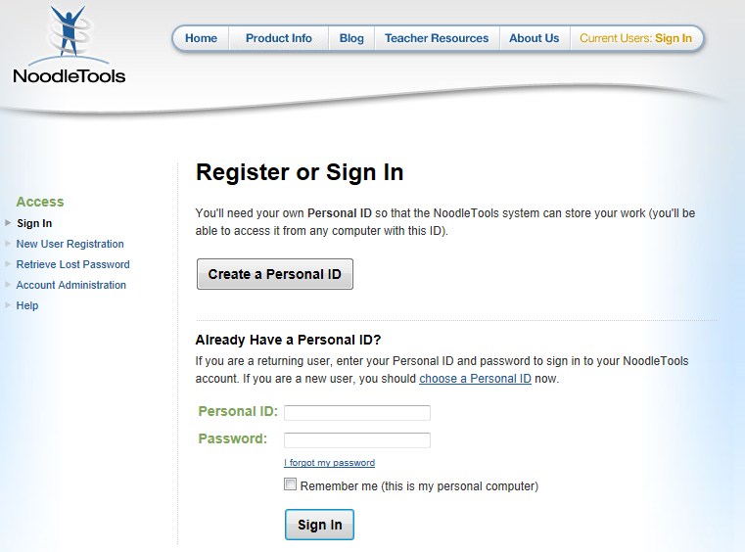
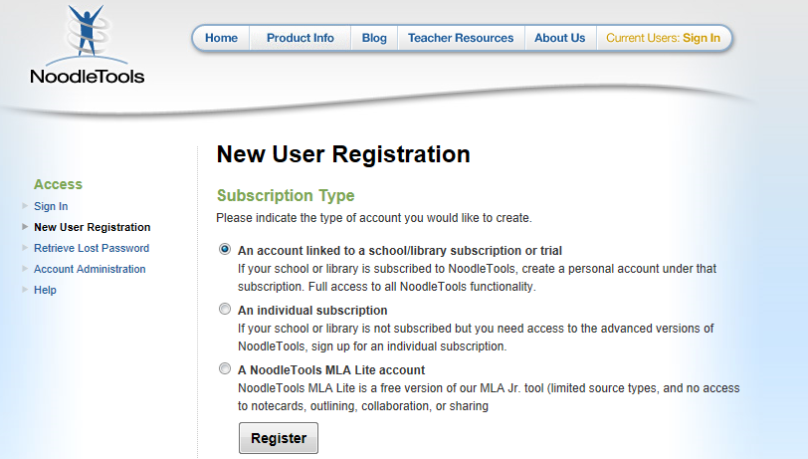

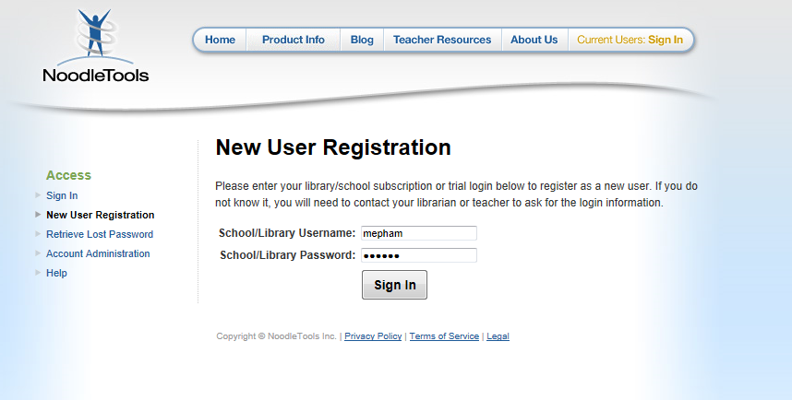

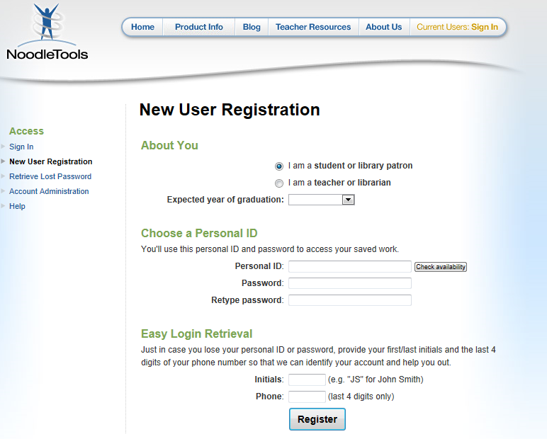
7. Create username and password for your account
Creating a new project
To create a new project, click the Create a New Project button in your personal folder (with My Projects selected). On the Create a New Project screen, you must provide some information before NoodleTools allows you to begin a project:
→ Step #1: Choose the source list style
- Choose MLA
→ Step #2: Choose the project level
- Choose Junior: Middle school or high school ESL learners
→ Step #3: Provide a brief description
Enter a brief description that will help you remember the contents of this project when you see it later among other projects in your personal folder. Ex: 9th Grade Research Paper
At the bottom of the page, click Create Project to begin a new project. If you change your mind, click Cancel to return to your personal folder.
Adding citations
→ In the navigation bar at the top of the screen, click Bibliography to begin adding citations to a new project. You will see a dropdown list with the label “Cite a:” that contains all of the citation types available.
The content of the dropdown list will vary depending on what project level you selected.
Creating a citation
→ Click the Create Citation button after you have made your selection from the dropdown list.
→ Depending on the source you are citing, a help screen appears.
o A Show Me link begins an online tutorial to demonstrate how to evaluate the source.
o A Source Check area lists other related forms that may better fit your source.
o If you are comfortable citing a particular type of source and wish to hide this additional help, check the “Hide this help screen next time” box at the bottom of the page.
→ Click Continue to go to the citation form.
→ Fill in as many details about your source as you can locate. Help text pops up with tips as you move from field to field.
→ A formatting guide at the top-right of the screen displays a citation template. Click the blue tab (“MLA Guide” in the screenshot below) to open the guide. As you enter information in the form, the citation element is highlighted with a blue box in the template.
Printing
The final version of your source list should always be printed.
- Exporting as a Google Docs paper
→Click Print/Export to Google Docs
→ A new window will be opened prompting you to sign in with your Google Account. If no window appears, disable your pop-up blocker and retry.
→ When you log in, NoodleTools will request access to your Google Account. Click Grant access button. Your source list will appear in a Google Docs paper.
- Exporting as a Word document
→Click Print/Export to Word

