Name ___________________________________ March 6, 2014
Mr. Morris/Ms. Vetro

Do Now: What groups have been discriminated against in America? In your opinion, do you believe the country has made advances in this area? Do you think that, as a country, we are more tolerant and accepting? Explain your answer below.

Shirley Chisholm
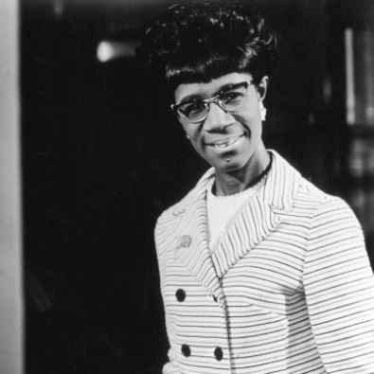
Born in Brooklyn, New York, in 1924, Shirley Chisholm is best known for becoming the first black congresswoman (1968), representing New York State in the U.S. House of Representatives for seven terms. She went on to run for the 1972 Democratic nomination for the presidency—becoming the first major-party African-American candidate to do so. Throughout her political career, Chisholm fought for education opportunities and social justice. Chisholm left Congress in 1983 to teach. She died in Florida in 2005.

“Equal Rights for Women”
Questions  Who is the author? | Notes
What type of text is this?

Who is the audience?

Questions | Answers
- What is prejudice?

- According to Chisholm, what are the assumptions of the “calculated system of prejudice” that lies behind the question “Do you type?”

- Look at paragraph 4, what does the author mean by the “happy little homemaker”?

- Look at paragraph 4, what does the author mean by “contented ‘old darkey”?

- What technique is being used? (hint: comparing two subjects that are similar in some way)

What is the claim? ________________________________________________________

Track the evidence: (Give two statistics to back up the claim)
#1

#2

What is the purpose to her speech? (hint: what does she propose?)

Your thoughts: Do you think changing the law is an effective way to eliminate prejudice and discrimination? Why or why not?

